**Report 1 (Week 1)**

1. Introduction

A brief introduction about neural networks. What does it do, what place it has in machine learning studies etc.

.

.

.

* 1. Perceptrons

Basic things about perceptrons. This is an actual introduction to neural networks. It has a input and output scheme like this.

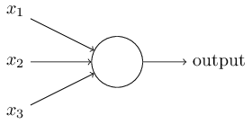

It has weights for the importance of the Xj. For example, if X2 has more importance than X3 or X1, it has bigger weight and it directly affects the output.



1.2 Sigmoid neurons

This scheme explains the effects of changing weights to the output.

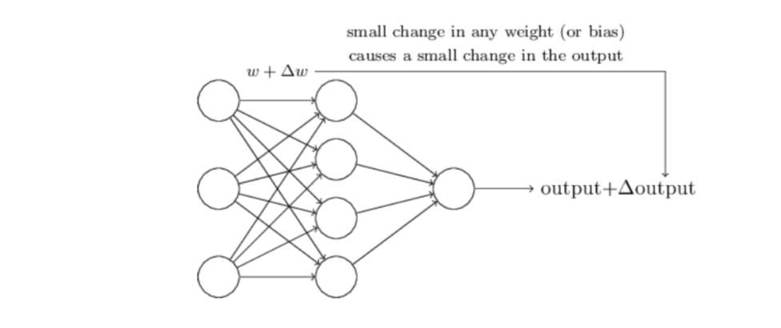

But this is not a healthy example with perceptrons. Little weight change can cause the output from 0 to 1 or from 1 to 0. And this is not a good thing to happen us. Therefore we are introduced with a new neuron that is called sigmoid neuron. It can have a value of any number in the range of from 0 to 1. Not just 0 or 1.

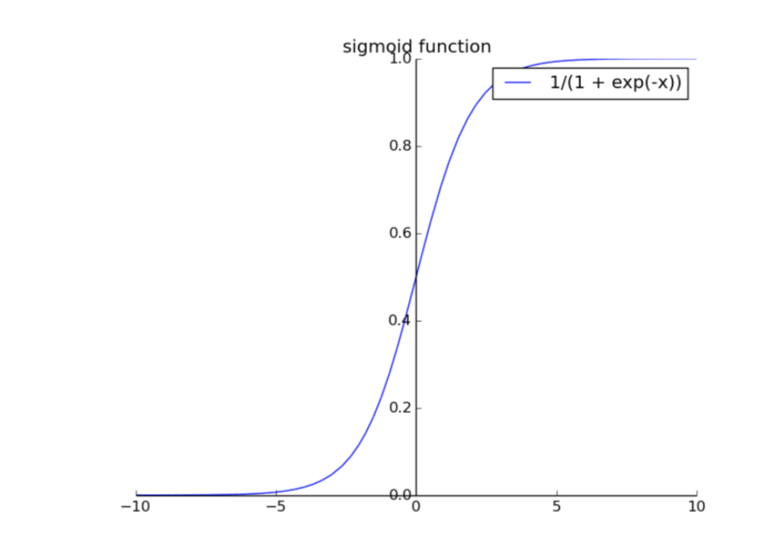



1.3 The architecture of neural networks

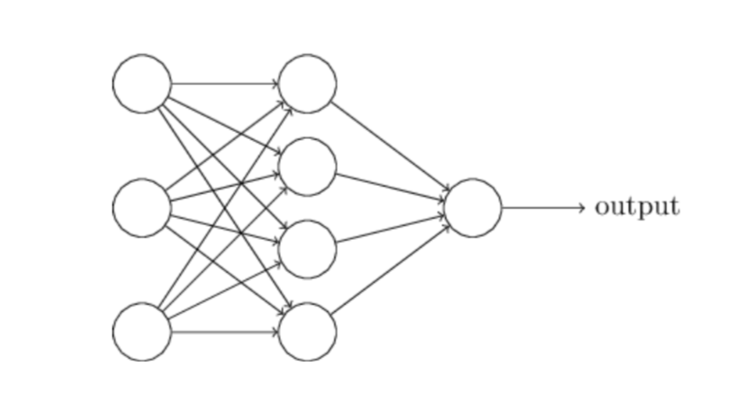

This is a simple architecture of neural networks.

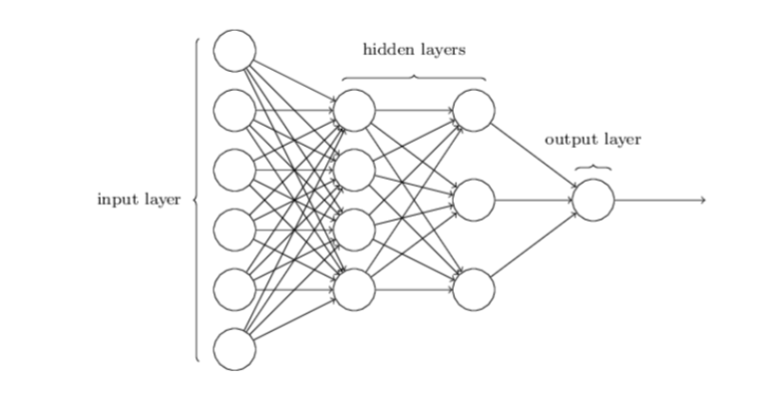

More complicated one with hidden layers etc.

1.4 Gradient Descent Algorithm

Gradient descent is a [first-order](https://en.wikipedia.org/w/index.php?title=First-order_method&action=edit&redlink=1) [optimization](https://en.wikipedia.org/wiki/Mathematical_optimization) [algorithm](https://en.wikipedia.org/wiki/Algorithm). To find a local minimum of a function using gradient descent, one takes steps proportional to the negative of the gradient (or of the approximate gradient) of the function at the current point.

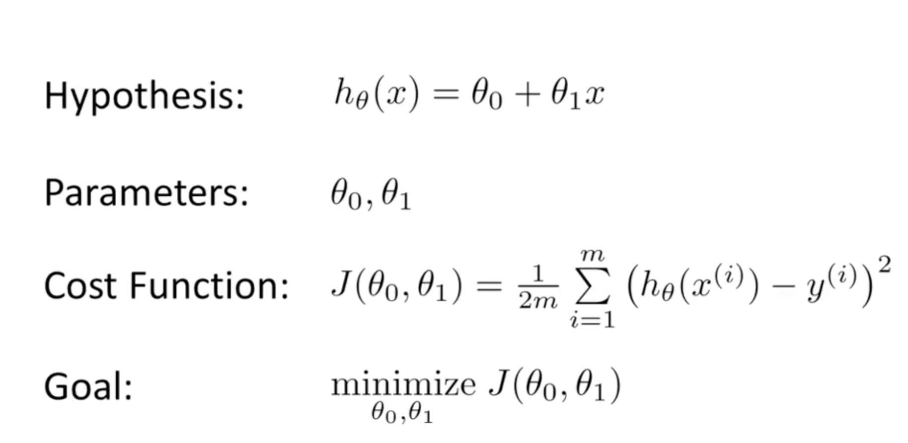

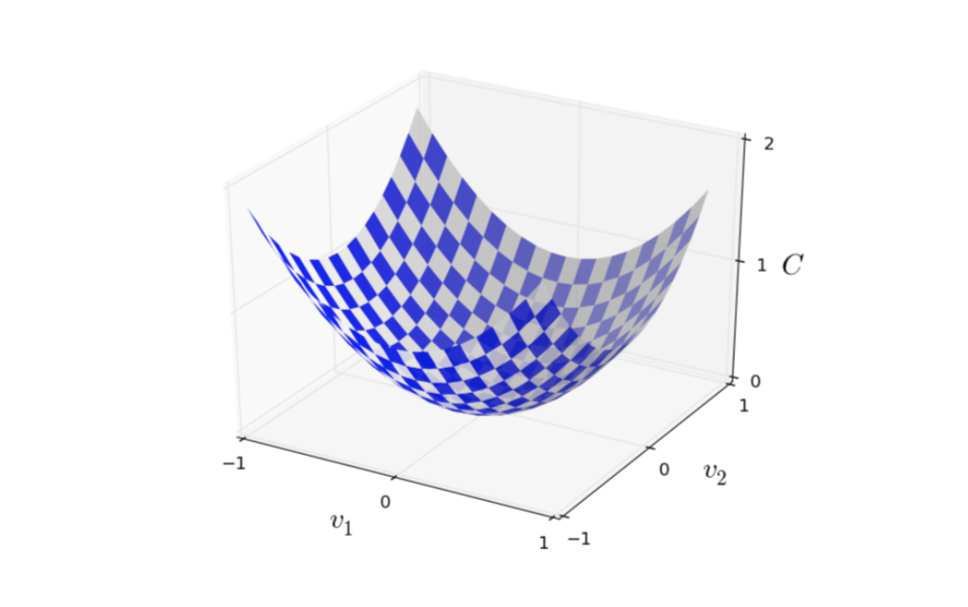

Sample cost function with two variables.

1.5 Implementing our network to classify digits

Get the codes from https://github.com/mnielsen/neural-networks-and-deep-learning

It has an output like this:

Epoch 0: 9129 / 10000

Epoch 1: 9295 / 10000

Epoch 2: 9348 / 10000

...

Epoch 27: 9528 / 10000

Epoch 28: 9542 / 10000

Epoch 29: 9534 / 10000

Codes will be added.